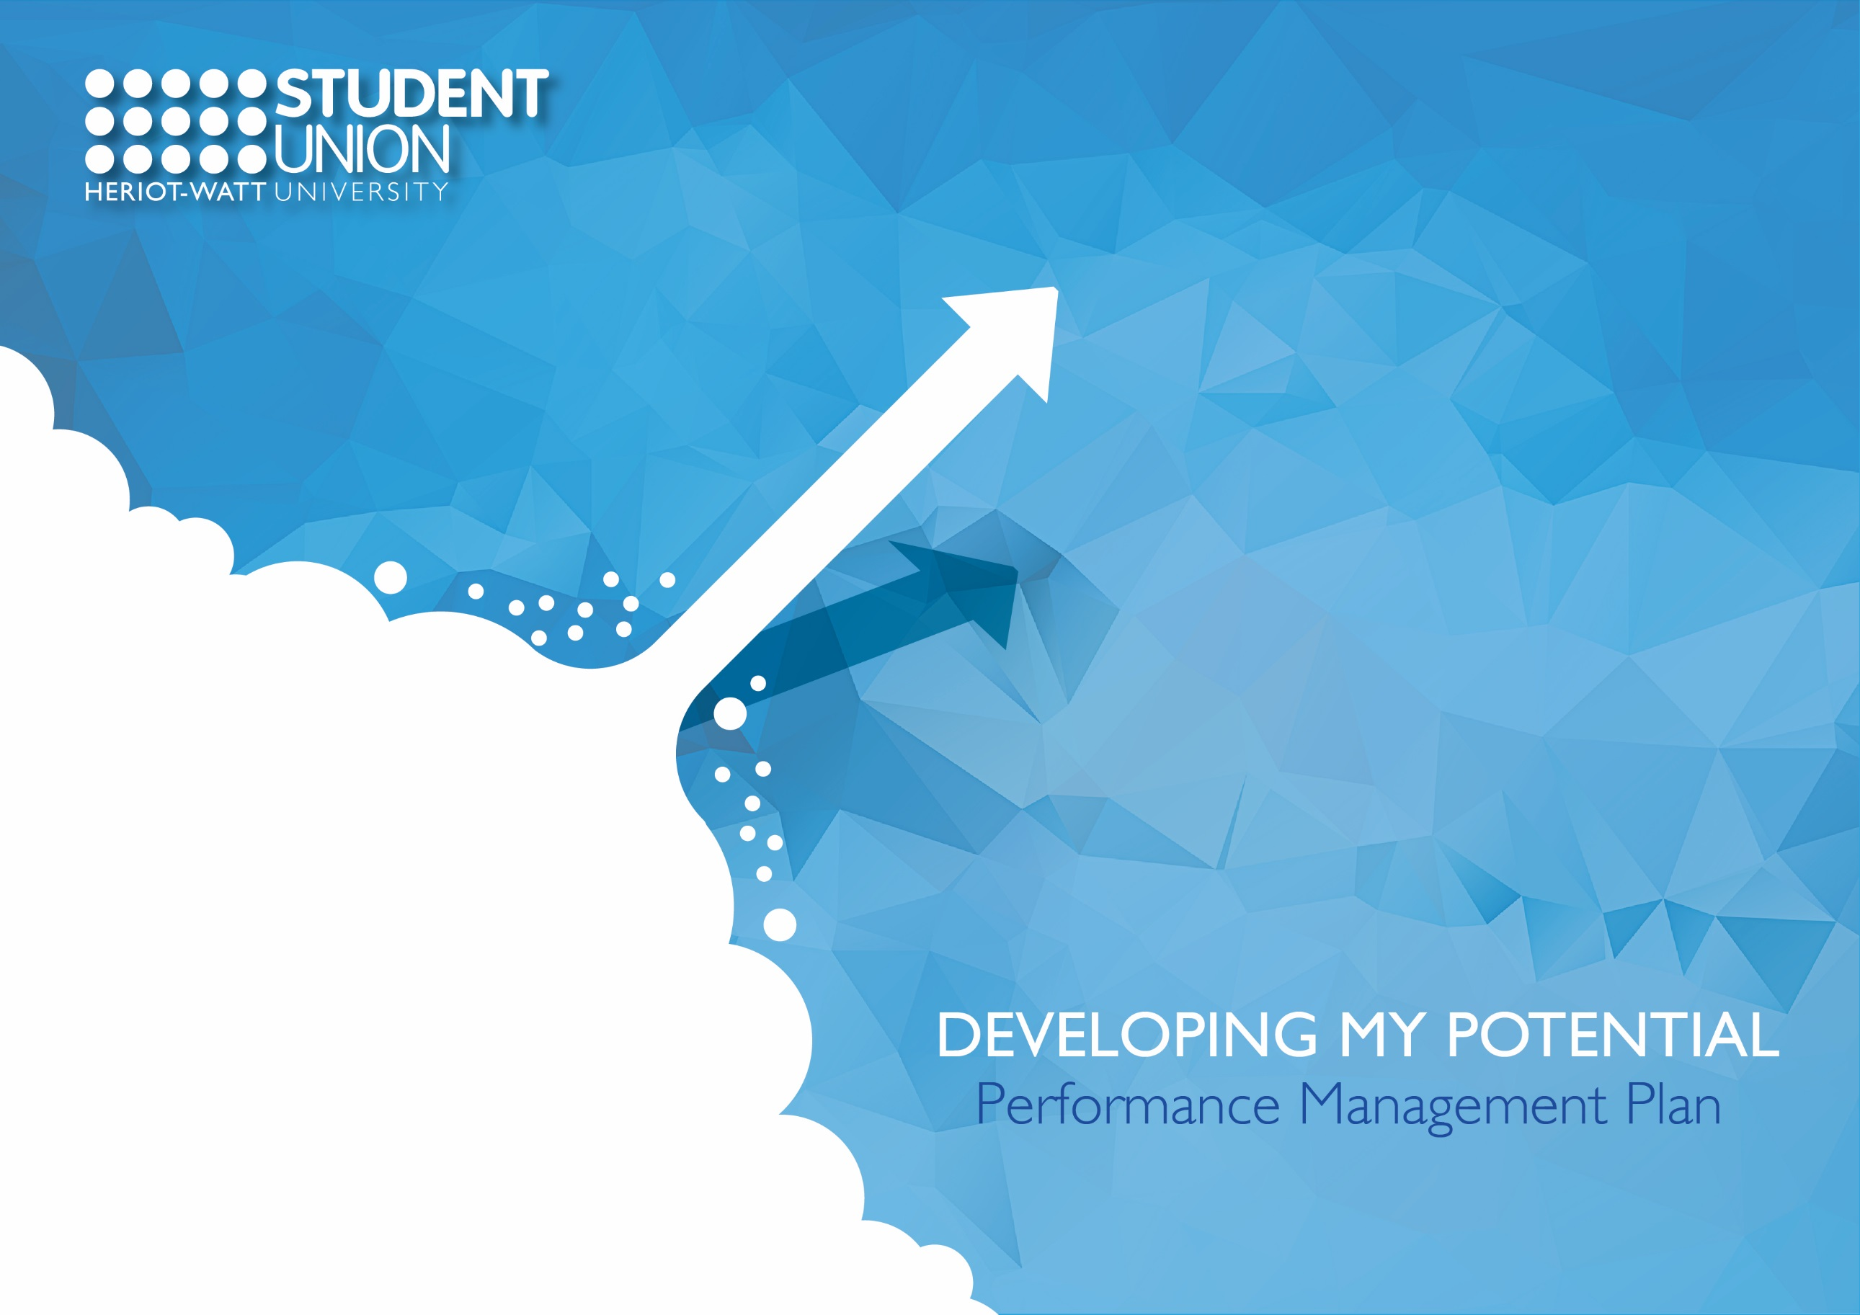
Date of first completion:
Manager/Reviewer:
Job Title:
Name:
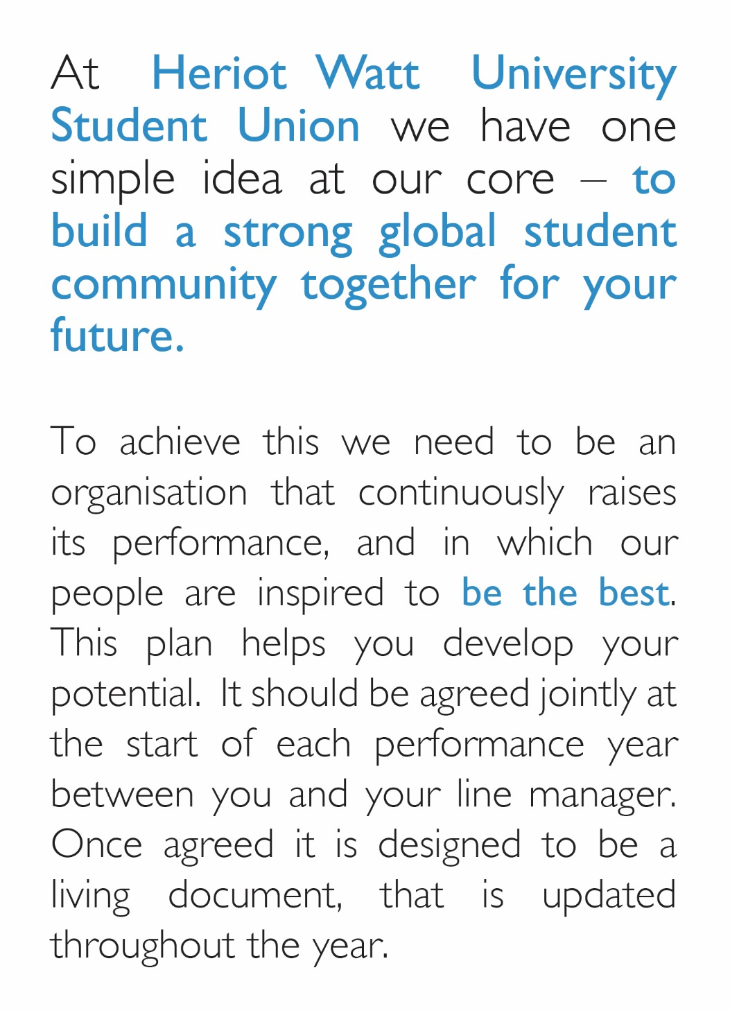
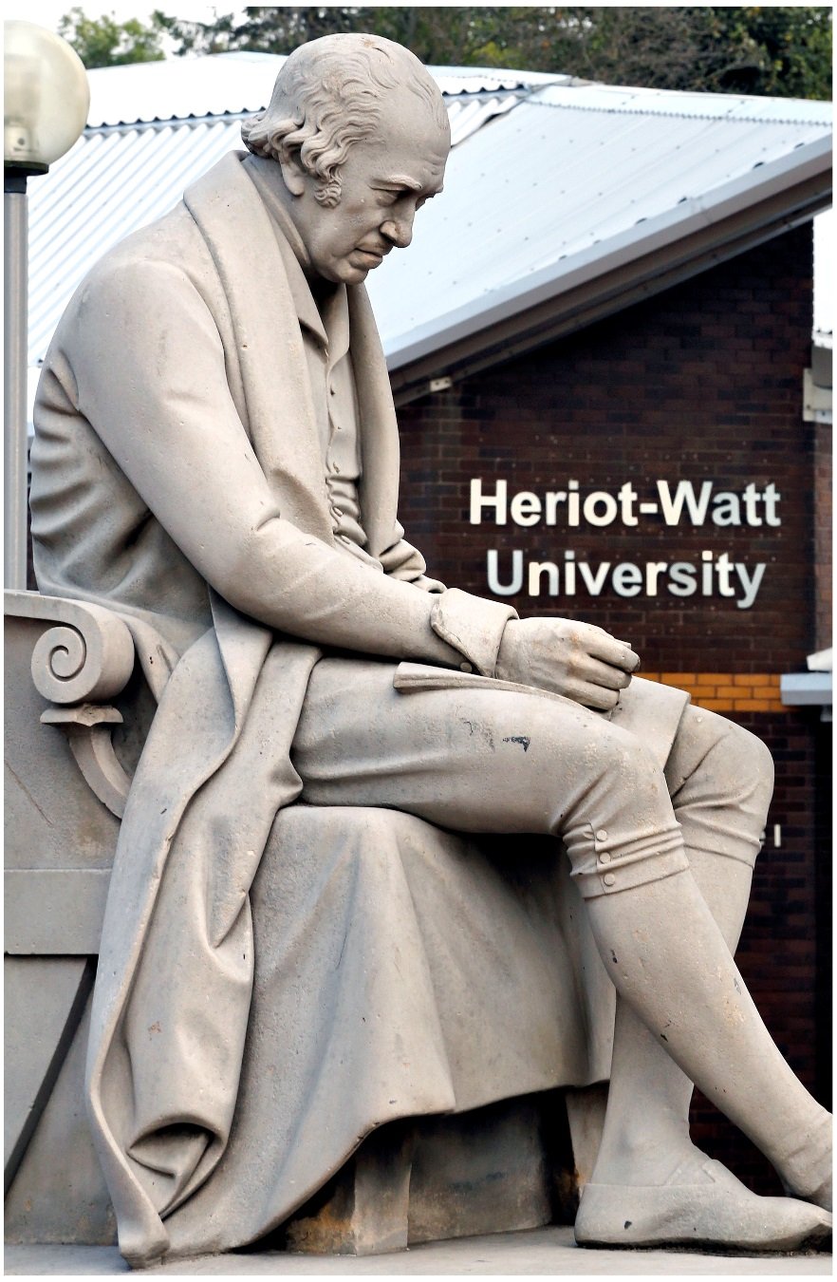

Section One: Your Objectives
Objectives describe the areas of key focus within your role within the coming year and should be informed by our strategic and operational plans, your departmental plan and your areas for behavioural development based on the Competency Framework. They should be realistic while providing stretch for you to continually develop.

Date | Objective  What is it that you/your team want to achieve? | Date | Actions or deliverables  What individual actions will you need to take to achieve your objective? | Timescales  When does this need to be completed by? | Success Measures or Outcomes  How will you track or measure your performance | Progress update  To be updated before each meeting
 | 1.
 | 2.
 | 3.
 | 4.
 | 5.
 | 6.

Section Two: Your Learning and Development Plan
Based on your objectives, what learning and development will you focus on?
Area for development  Skill, knowledge or competency | Action plan  What steps will you take to achieve this? | Success Measure or Outcome  How will you know you've improved? | Timescale | Progress

Section Three: Your 1:1’s
Throughout the year you'll have regular 1:1's with either your manager or someone else who is responsible for you on shift to review your progress against your performance plan and to discuss your development.
Date | Overall progress against Performance Plan  What have you achieved in terms of your objectives, have you demonstrated the competencies, and how are you developing? | Learnings  What's gone well, what would you do differently next time? | Outputs  Actions for you and your manager

Section Four: Year End Review Preparation
This section should be completed by you one week before your Year End Review meeting and shared with your manager.

Date of Meeting:

Performance Against Objectives
Which achievements and outcomes are you most proud of and why?

If you could have done anything differently in the delivery of your objectives what would it have been and why?

Performance Against the Competency Framework
Which competencies do you actively role model and are strengths?

Which competencies do you need to visibly demonstrate more often and how could you do this?

Performance Against Your Learning and Development
What have you learned through your personal development activities?

How has this learning benefited your current role and the Union?

Section Five: Summary of the Year

Staff Member Summary of the Year
Start date in Role:
Manager/Reviewer Summary of the Year and Rating
Reviewer Name:
Rating:

